Mary Dean’s CE Primary School

Welcome to the fortnightly newsletter.

Field Gun Taster Event
Wednesday last week saw a team from ‘Future Fit’ come in and give UKS2 a taster session in Field Gun drill. The children had an assembly telling them about the history of Field Gun and why it is important to keep the tradition alive. They then went out in groups to try their hands at the drill themselves A great time was had by all with superb teamwork and enthusiasm from the children. Mr Peters will be looking to gauge interest for forming a team and hopefully taking part in the event at Armed Forces Day on Plymouth Hoe in June.
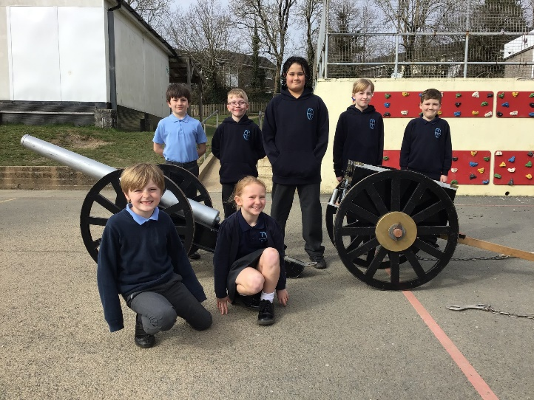

Parent Council
I am delighted to inform you that we have filled our parent council member vacancy. Becky Chinnock will be joining the First Federation Trust Hub Board on behalf of our school. Congratulations, Becky!
Save the Date
Parents meetings will be held on:
Thursday 21st March 3:30-5:50pm
A school family, learning for life in all its fullness. John 10:10

Our Achievers last week.
Well done!

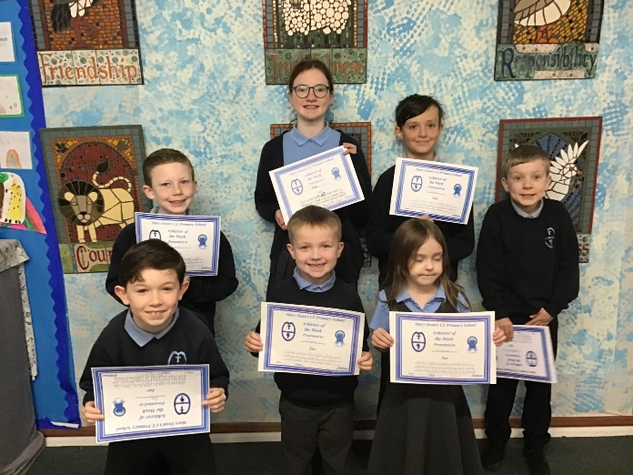

We have registered to take part in the Sustrans Big Walk and Wheel event again this year. The week to walk, cycle or scoot to school is 11th-22nd March. More details to follow.

Reminder
Last day for Tempest photos order is:
Monday 18th March

Our Achievers this week.
Well done!

Our Achievers this week.
Well done!

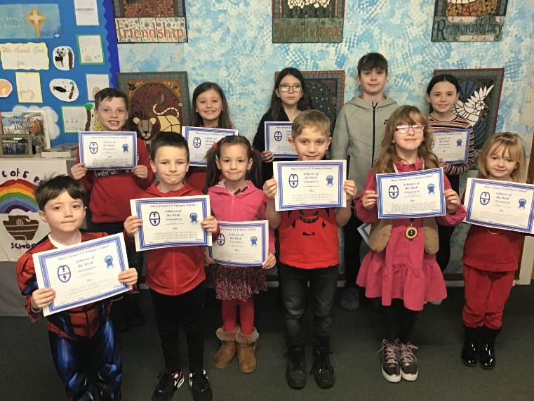

Sporting Achievements
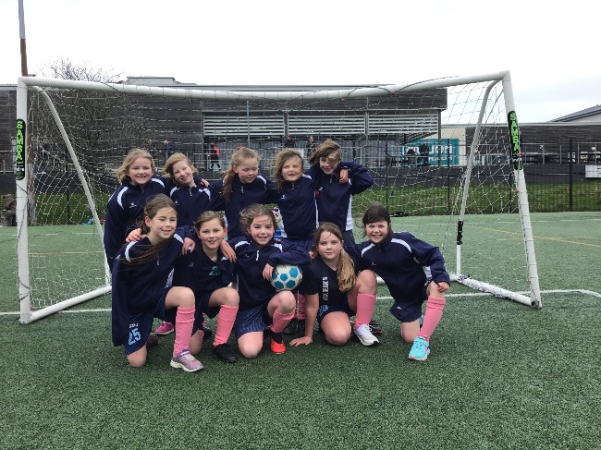
Mary Dean’s Y3/4 girls headed to the tournament at Marjons full of energy despite windy conditions. For some of the team it was their first time playing and all acquitted themselves admirably, even though the goals posts quite literally moved at times due to the weather! The highlight of the afternoon was an 8-0 victory with Aoife getting an amazing double hat trick! Monroe and Ava also getting in on the scoring with some skilful play! It is early days yet for the team, but with more events planned in the coming months, the girls will be hoping to build on this success.

A school family, learning for life in all its fullness. John 10:10

The team looked the part in their new kit!

David Hill Sponsorship
Using the £1600 the children raised in October as sponsorship money for the event day with Paralympic athlete, David Hill, the Sports Leaders chose to spend the money on sports equipment to improve our break times, P.E lessons and provide us with new after school clubs. In the summer term, Argyle will be running an archery after school club with our new equipment. Children in Y3/4 have already enjoyed dancing with the new rainbow ribbons, this week.
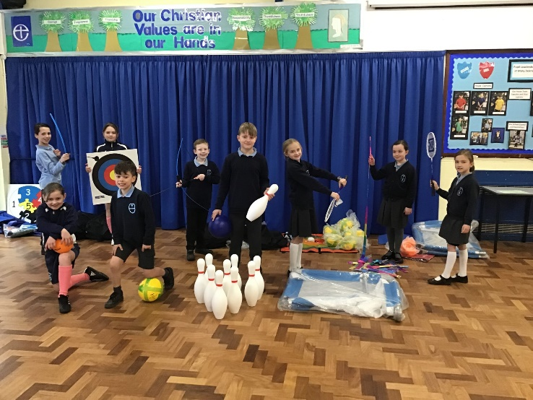

Staffing Changes
We are always sorry to see staff leave as we think of ourselves as one big family here at Mary Dean’s. But life moves on, and changes invariably happen.

We need to congratulate Mrs Childs who has taken up post as SEMH lead in the First Federation Trust. She will continue to work with us but will also be branching out into the other schools in the Trust. She will finish her SENDCo role at Easter. Thank you, Mrs Childs for everything you have done to support our children and families in the time you have been here. We wish you continued success in your new role.

Our new SENDCo, Sharon Higginson is currently SENDCo at Marine Academy and is very excited about starting at Mary Dean’s after Easter.

Mrs Loveridge, our senior administrator will also be leaving us at Easter. She has been working at the school for 8 years and is the font of all
financial knowledge. She will be missed and we
wish her all the best with her future plans.

Miss Foster will be returning from maternity leave after Easter which means we will be saying goodbye to Miss Pooley. Miss Pooley has been teaching our youngest children in the Nursery and has become part of the Mary Dean’s furniture! We wish her all the best in her future plans.

Attendance Policy
We are updating our attendance policy and there will be some changes that parents/carers will need to become familiar with. We will send out further information in due course.

A school family, learning for life in all its fullness. John 10:10

World Book Day
Another splendid turn out again for World Book Day. Some fantastic costumes and a great week of activities organised by Mrs Butchers, our English lead. Thank you to everyone who took part. Here are the winners from each class who won a book voucher courtesy of our PTFA.
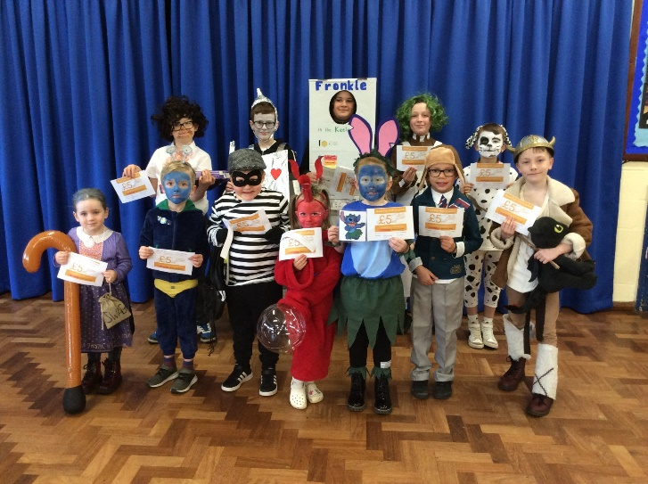

Thank you for your continued support.

Donna Wilson
Head Teacher

