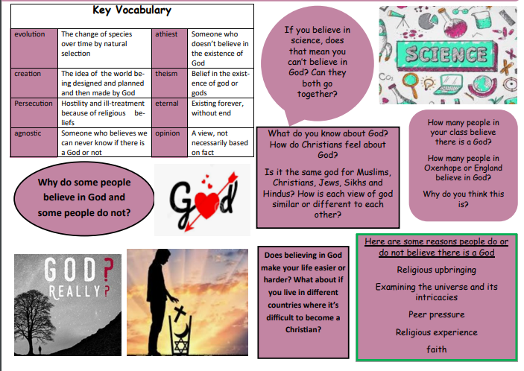

How many people in Plymouth believe in God?