UKS2 Spring Cycle 2 History Knowledge Organiser: The Elizabethan Age.
Queen Elizabeth 1st reigned from 1558-1603  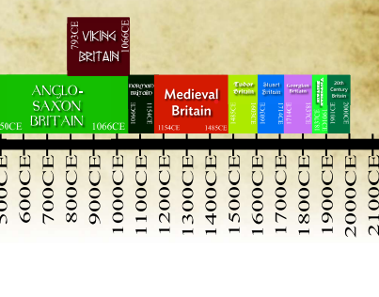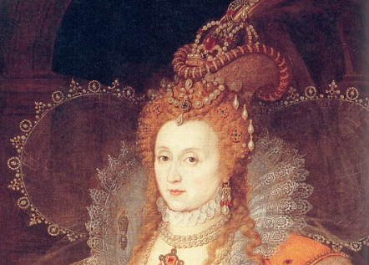 | Know that:  - Queen Elizabeth was born in 1533.  - She was the daughter of Henry V111 and his second wife, Anne Boleyn.  - She was 25 when she ascended to the throne and reigned from 1558-1603.  - She was known as the Virgin Queen as she never married.  - Her reign is known as ‘The Golden Age’ as it was a time of immense progress and stability.  - During the Elizabethan era, England became a major European power and increased its trade routes across the globe.  - Sir Francis Drake was a Naval hero who played a pivotal part in Elizabethan times.  Know how:  - To explain how religious differences challenged Queen Elizabeth 1^{st’s} reign, and how she sought a ‘middle way’ between Catholics and Protestants.  - To analyse evidence sources to find out how Queen Elizabeth was portrayed during her reign.  - To order dates and events chronologically.  - To explain how society was ordered hierarchically in Elizabethan times.  - To discuss the impact of Sir Francis Drake on the legacy of Elizabeth 1st’s reign.
KEY VOCABULARY | GLOSSARY
Hierarchy | A system in which members of society are ranked by status.
Great Chain of Being | A hierarchical structure of all matter and life thought by Christians to have been decreed by God.
Catholic | A Christian who follows the Catholic religion as transmitted through the Pope.
Protestant | A Christian who follows any church separate from the Roman Catholic Church.
Monarch | A sovereign head of state.
Parliament | A group of elected politicians who make the law for their land.
Circumnavigated | A law, or bodies of law, passed by the Central Government of America.

