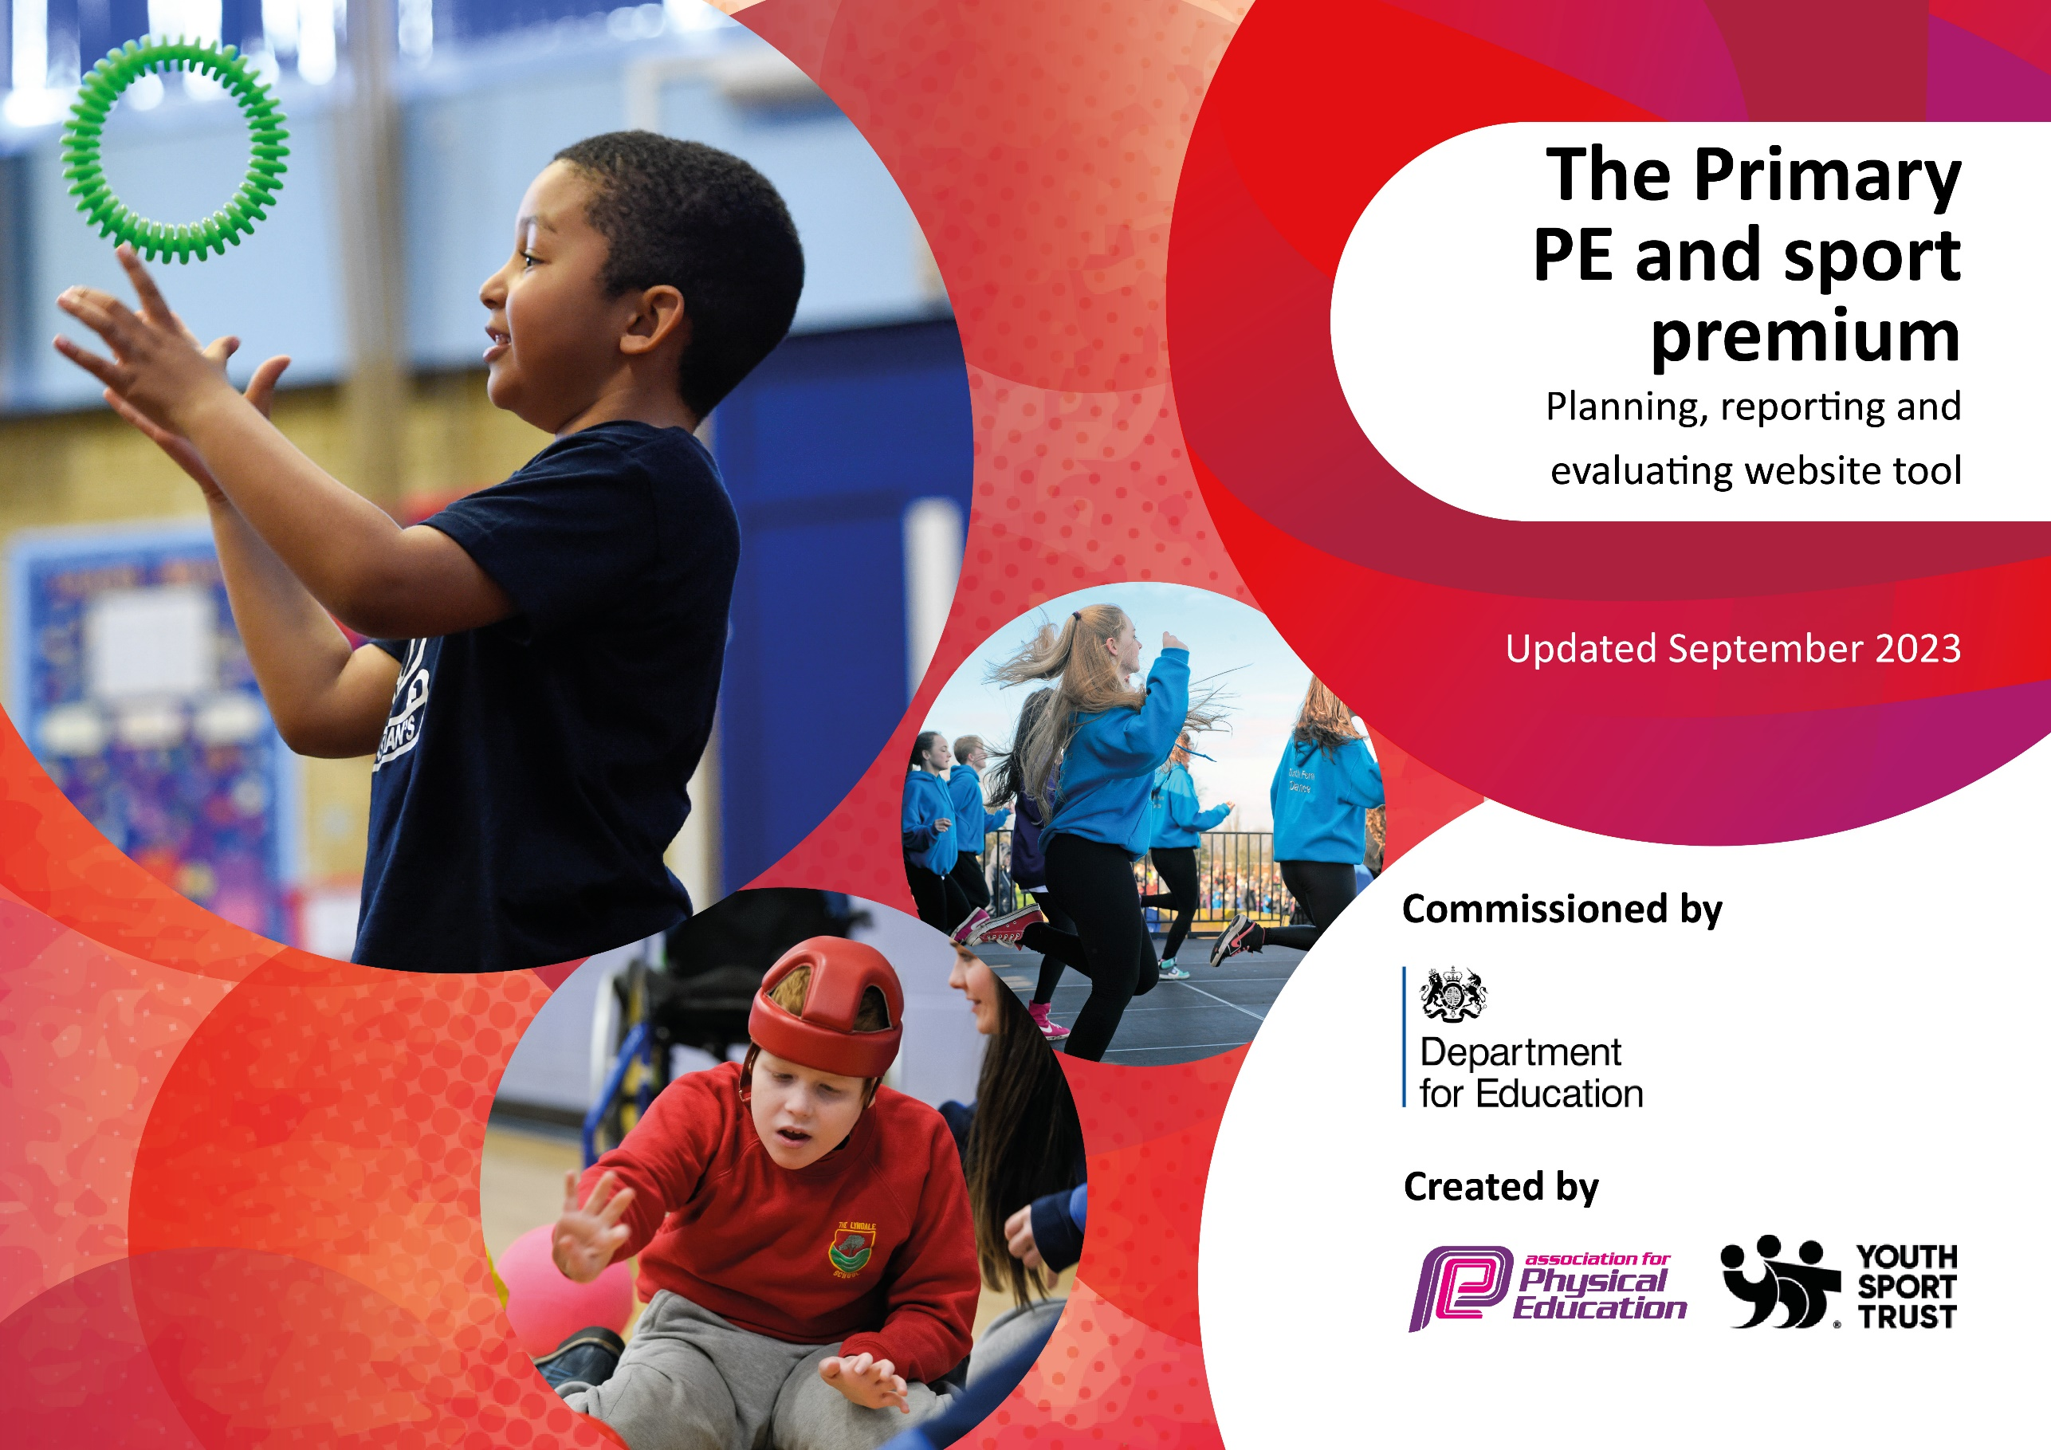

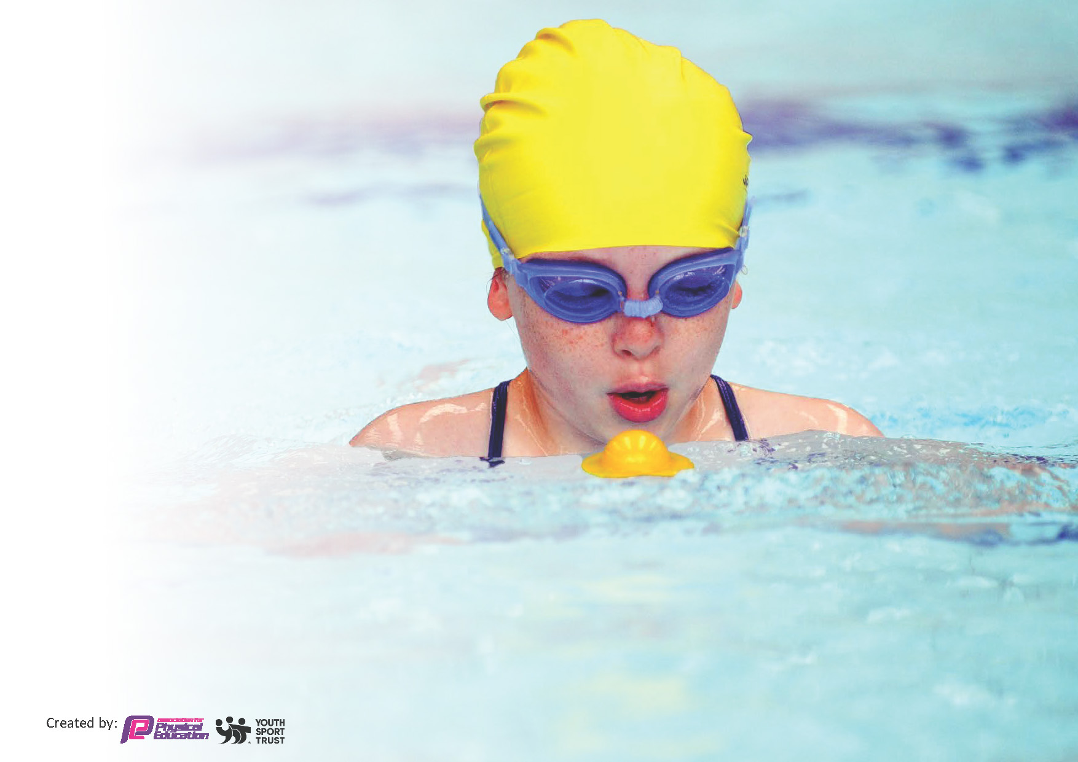
This template can be used for multiple purposes:
by:
- It enables schools to effectively plan their use of the Primary PE and sport premium
- It helps schools to meet the requirements (as set out in guidance) to publish information on their Primary PE and sport premium
- It will be an effective document to support Ofsted inspections enabling schools to evidence progress in Physical Education (PE) and evidence swimming attainment, which forms part of the PE National Curriculum. We would recommend schools consider
the Intent, Implementation and Impact of any spend, as examined within the Education Inspection Framework.

It is important that your grant is used effectively and based on school need.

Schools must use the funding to make additional and sustainable
improvements to the quality of the PE, School Sport and Physical Activity (PESSPA)
they offer. This means that you should use the Primary PE and sport premium to:

- Build capacity and capability within the school to ensure that improvements made now will benefit pupils joining the school in future years
- Develop or add to the PESSPA activities that your school already offers.

The Primary PE and sport premium should not be used to fund capital spend projects; the school’s core budget should fund these. Further detail on capital expenditure can be found in the updated Primary PE and sport premium guidance.

The Primary PE and sport premium guidance, outlines 5 key priorities that funding should be used towards. It is not

necessary that spending has to meet all the key priorities, you should select the priorities that you aim to use any funding towards.

Although completing this template is not a requirement for schools, schools are required to publish details of how they spend this funding. Schools must also outline what the impact this funding has had on pupils’ PE and sport participation and attainment and how any spending will be sustainable in the future. All funding must be spent by 31st July 2024.

The Department for Education has worked closely with the Association for Physical Education (afPE) and the Youth Sport Trust (YST) to develop this template and encourages schools to use it. This template is an effective way of meeting the reporting requirements of the Primary PE and sport premium.
Review of last year’s spend and key achievements (2022/2023)

We recommend you start by reflecting on the impact of current provision and reviewing your previous spend.

Activity/Action | Impact | Comments
*Review of last years’ Sports Premium Funding published on website.

Key priorities and Planning
This planning template will allow schools to accurately plan their spending.

Action – what are you planning to do | Who does this action impact? | Key indicator to meet | Impacts and how sustainability will be achieved? | Cost linked to the action

Book top-up Swimming lessons for children who can not yet swim 25 metres. | Children who did not achieve the minimum requirement during their curriculum swimming. | Key Indicator 2: The engagement of all pupils in regular physical activity | More children able to swim safely and competently as we are allowing more time for them to develop their skills. | £200
Invest in outdoor play equipment for KS1 (climbing frame plus installation). | All KS1 children. | Key Indicator 2: The engagement of all pupils in regular physical activity | More pupils meeting their daily physical activity goal. More pupils encouraged to take part in physical play and activity. | £7,557.49
Purchase Half Marathon T-Shirts & Medals. | All KS2 children. | Key Indicator 2: The engagement of all pupils in regular physical activity | More children taking part in physical activity and competing in events. | £700
Update & replenish equipment for PE lessons & extra-curricular clubs. | All children/teachers. | Key Indicator 3: The profile of PESSPA being raised across the school as a tool for whole school improvement | Ensuring the curriculum is well resourced to support teachers in their delivery of high quality PE & provide children with significant time to develop their skills. A new scheme of work was purchased last year so we will require resources for different units of work. | £1,000
Purchase jumpers for Sports Leaders. A few more required to replenish stocks due to wear and tear. | KS2 Sports Leaders. | Key Indicator 3: The profile of PESSPA being raised across the school as a tool for whole school improvement | Raising the profile of sports leadership will encourage more children to aspire to the role. The Sports Leader role will help to engage younger children in structure physical play. | £100
Employ the PSSP to provide specialist CPD for teachers/ run competitions/ events/sports leadership training/ Bikeability/ Balanceability/ provide specialist support for the PE Coordinator. | Teachers and children. | Key Indicator 1: Increased confidence, knowledge, and skills of all staff in teaching PE and sport.  Key Indicator 2: The engagement of all pupils in regular physical activity  Key Indicator 3: The profile of PESSPA being raised across the school as a tool for whole school improvement.  Key indicator 4: Broader experience of a range of sports and activities offered to all pupils.  Key indicator 5: Increased participation in competitive sport. | Staff working alongside a specialist will receive bespoke support to raise their confidence levels in their delivery of high quality PE. PE Coordinator to attend the Primary PE Conference as CPD. Opportunities for children of all ages/ abilities to take part in appropriate competition. More children participating. More children involved in sports leadership. Ongoing support from our PE specialist to identify strengths and weaknesses. | £5,250
Subscribe to iMoves to provide teachers with resources for Dance. | Teachers and children. | Key Indicator 1: Increased confidence, knowledge, and skills of all staff in teaching PE and sport. | Providing staff with quality resources will positively impact teaching and learning in PE. To be reviewed at the end of the year to be required. | £836.40
Book Plymouth Fusion Wheelchair Basketball for an alternative experience for Sports Week. | All KS2 children. | Key indicator 4: Broader experience of a range of sports and activities offered to all pupils. | A wider range of children participating. New experiences to develop a passion for physical activity. More children involved in sports. | £120
Employ Plymouth Argyle to deliver some after school clubs. | All children. | Key indicator 4: Broader experience of a range of sports and activities offered to all pupils. | A more diverse offer will engage more children. More children taking part in regular activity. | £8,310
Book transport to events/ cover staff release time to attend. | All children. | Key indicator 5: Increased participation in competitive sport. | More children able to participate in appropriate competition. Transport negated as a barrier to participation. | £800
Purchase badges for School Games Day. | All children. | The profile of PESSPA being raised across the school as a tool for whole school improvement | A wide range of children encouraged to participate in School Games Day and receive a sense of achievement – developing a positive experience of PESSPA. | £50

Key achievements 2023-2024
This template will be completed at the end of the academic year and will showcase the key achievements schools have made with their Primary PE and sport premium spending.

Activity/Action | Impact | Comments

Swimming Data
Meeting National Curriculum requirements for swimming and water safety.
Priority should always be given to ensuring that pupils can perform safe self-rescue even if they do not fully meet the first two requirements of the National Curriculum programme of study

Question | Stats: | Further context  Relative to local challenges
What percentage of your current Year 6 cohort can swim competently, confidently and proficiently over a distance of at least 25 metres? | % | Use this text box to give further context behind the percentage.  e.g., 30% - we are struggling to get pool space due to our local pool closing so we have had to use a much smaller local school pool. We have had to limit the number of pupils attending swimming lessons during one term which means some pupils have attended fewer swimming lessons than others.
What percentage of your current Year 6 cohort can use a range of strokes effectively [for example, front crawl, backstroke, and breaststroke]? | % | Use this text box to give further context behind the percentage.  e.g., Even though your pupils may swim in another year please report on their attainment on leaving primary school at the end of the summer term 2024

What percentage of your current Year 6 cohort are able to perform safe self-rescue in different water-based situations? | % | Use this text box to give further context behind the percentage.
If your schools swimming data is below national expectation, you can choose to use the Primary PE and sport premium to provide additional top-up sessions for those pupils that did not meet National Curriculum  requirements after the completion of core lessons. Have you done this? | Yes/No
Have you provided CPD to improve the knowledge and confidence of staff to be able to teach swimming and water safety? | Yes/No

Signed off by:

Head Teacher: | (Name)
Subject Leader or the individual responsible for the Primary PE and sport premium: | (Name and Job Title)
Governor: | (Name and Role)
Date:

