Year 5/6

Animals including Humans

**Knowledge Organiser**

VOCABULARY

**Heart**- the organ in your chest that pumps the blood around your body.

**Blood vessels**- the narrow tubes through which your blood flows include the arteries, veins and capillaries.

**Blood**- this is pumped by the heart and supplies the body with nutrients and oxygen.

**Veins**- blood vessels that carry blood to the heart.

**Arteries**- blood vessels that carry blood away from the heart.

**Capillaries**- microscopic blood vessels found in the muscles and lungs.

**Oxygen**- a colourless gas that exists in large quantities in the air. All plants and animals need oxygen in order to live.

**Lungs**- two spongy organs inside the chest which fill with air when you breathe in.

**Carbon dioxide-** is a gas produced by animals and people breathing out.



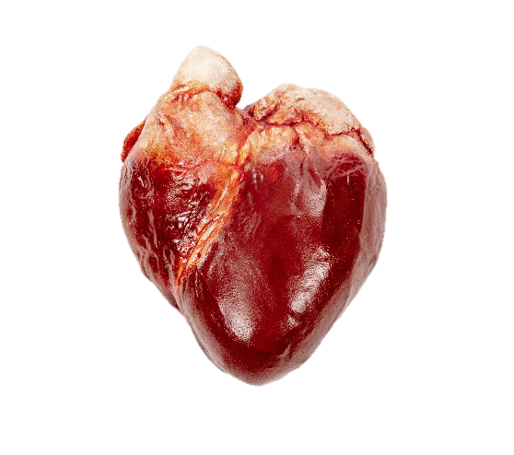**r**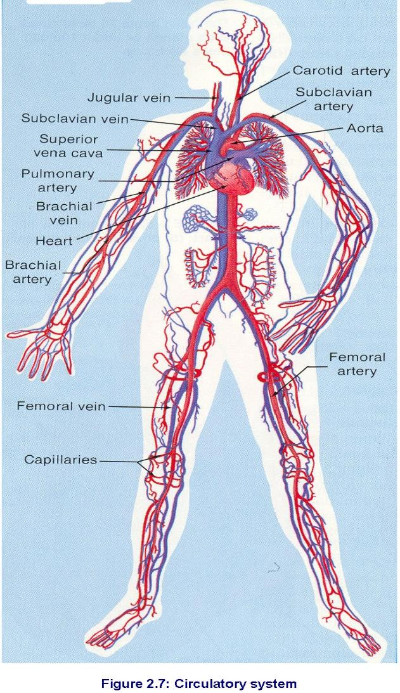

nnh



It works as a pump forcing blood around the body. The heart is mainly muscle and it works from the moment you are born until death. It works harder when you exercise.

Deoxygenated blood flows into the heart from the body through veins.

This blood is pumped out to the lungs through the pulmonary artery.

Blood returns to the heart through the pulmonary vein.

The oxygenated blood is then pumped out of the hear through the aorta.

The blood travels around the body delivering oxygen and nutrients to the organs.

The circulatory system is the system that circulates blood through the body.