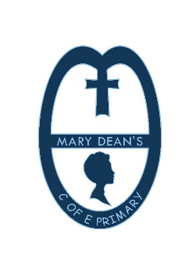
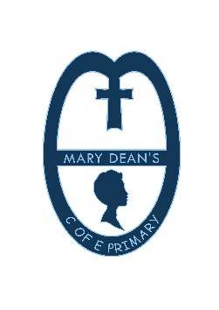
Mary Dean’s CE Primary School
Policy Statement
Subject: Music
A School Family Learning for Life in all its Fullness

Aims
The school believes that music is a powerful, unique form of communication that can change the way pupils think and act. Music aids the development of imagination by experiencing emotions and feelings beyond their present knowledge. The National Curriculum for music aims to ensure that all pupils perform, listen to, review and evaluate music, be taught to sing, create and compose music and understand and explore how music is created, produced and communicated.
- At Mary Deans pupils develop their independent creativity and express themselves through music.
- To develop the child’s music knowledge and skills through composing, performing, and listening and appraising. Children also develop an understanding of standard notation and apply this knowledge when performing.
- To further develop these skills to complement all areas of the curriculum.

- To extend and develop children’s awareness and understanding of musical traditions, genres, and composers and artists from a variety of cultures and historical periods.
- To provide a range of opportunities to contribute to the community and the school’s ethos.
Objectives
By selecting appropriate teaching strategies and differentiation the music teacher directs and develops pupils’ musical knowledge and skills. Teaching across the school enables the teacher to guide and track individual progression over time. Pupils work as a whole class, in smaller groups and individually. Younger children will learn notation initially through pictures and grid notation to allow understanding of pitch, rhythm and dynamics. Similarly, older children will develop reading standard notation and common musical terms in line with music progression maps. Composition in younger children mainly takes place as a whole class, whilst KS2 children develop composition in small groups, pairs, and individual work. This allows children to build strategies for working with others and develop their ability to evaluate their own and others’ work. Children in KS1 and KS2 are taught in a dedicated music room. Specific music displays allow pupils to access terminology and a range of instruments. Resources are routinely audited and adapted to the needs of the music department. A selection of 'small hands' instruments have been purchased for the youngest children in the school. These are also available for children who have limited or weak motor control. Regular communication with SEND coordinator enables the music teacher to plan according to individual’s targets.
Procedures
Pupils will receive a broad and balanced curriculum with sufficient time provided to teach music to enable progression in knowledge, skills and understanding. There are 18 hours allocated for music at Foundation stage and Key Stage 1 and 26 hours per year at Key Stage 2. In KS1, children have weekly sessions throughout the year. At KS2 children will experience planned, class-based music for 4 half terms a year for 1 hour per session. In Reception, children have a weekly 30-minute lesson and they experience music through play in line with the Early Learning Goals. In KS1 each lesson is 40 minutes in duration. In KS2 lessons are 1hour long. All teaching follows a carefully planned set of units developed and approved by the joint music coordinators. Objectives are taken directly from the National Curriculum implemented in September 2014. Music teaching is planned and delivered across the whole school by a specialist music teacher, Mrs Williams. Each unit of work for music is designed to develop skills and understanding through involvement in the interrelated activities of performing, composing, appraising and listening. Similarly, pupils experience and discuss the work of great composers and artists through historical and social contexts. Music planning is linked with other curriculum subjects where appropriate. Children also experience First Access opportunities such as singing, recorder, ukulele, keyboards, and glockenspiel throughout KS1 and KS2. These are designed to give children a taste of learning a specific instrument with the potential for further learning outside the classroom.
Mrs Dove and Mrs Elliott provide music opportunities outside the classroom including Year 6 performances, a KS1 Musical Nativity, assemblies and out of school activities. Children also develop performance skills through public performances, concerts and arts theme weeks. The choir has strong links with the community, conducting performances at Christmas for the elderly and singing at the Lord Mayor’s Carol Service. All pupils have the opportunity to take part in extra-curricular activities such as choir and KS1 singing club. Additional opportunities for listening, appraising, and applying knowledge are provided as children enter the hall for assemblies or hymn practices where a variety of music types/styles are played. Instrumental peripatetic tuition is provided by ‘Mr Dove’s Music’. Mr Dove and his staff visit the school once a week to teach a range of instruments.
Monitoring
The joint music coordinators are responsible to the headteacher and the governing body for standards achieved, the quality of teaching and learning and the management of music throughout the school. Feedback to pupils about their own progress in music aims to help children learn by being positive and constructive. Feedback is always given whilst a task is being carried out through discussion between child and teacher and carefully directed questioning. Formative assessment is also used to guide the progress of individual pupils in Music. Assessment is carried out at the end of each unit of work against a prescribed set of learning objectives. The proforma allows the music teacher to inform class teachers of specific targets and achievements of individual children. Progress in music is also evidenced through video and audio recordings and photographs (parental consent for photographs is given). These are stored on the school server. An overview of progression from Reception to Year 6 is set out on the network and in the Music Coordinator’s folder.
Review
The music policy will be regularly reviewed by coordinators. Similarly, music planning, assessment and progression of skills and knowledge will be monitored by regular meetings with Mrs Dove and Mrs Williams. To maintain teaching standards and keep abreast of new ideas and pedagogy subject leaders will:
- Attend music conferences
- Continue to develop working relationships with Plymouth Music Hub and Plymouth Music Coordinator by attending twilight sessions and asking for relevant advice.
- Arrange for other artists to visit the school.
- Maintain resources for each unit of work.
- Represent the school at the Academic Council’s annual music conference and events.

UPDATED September 2021

