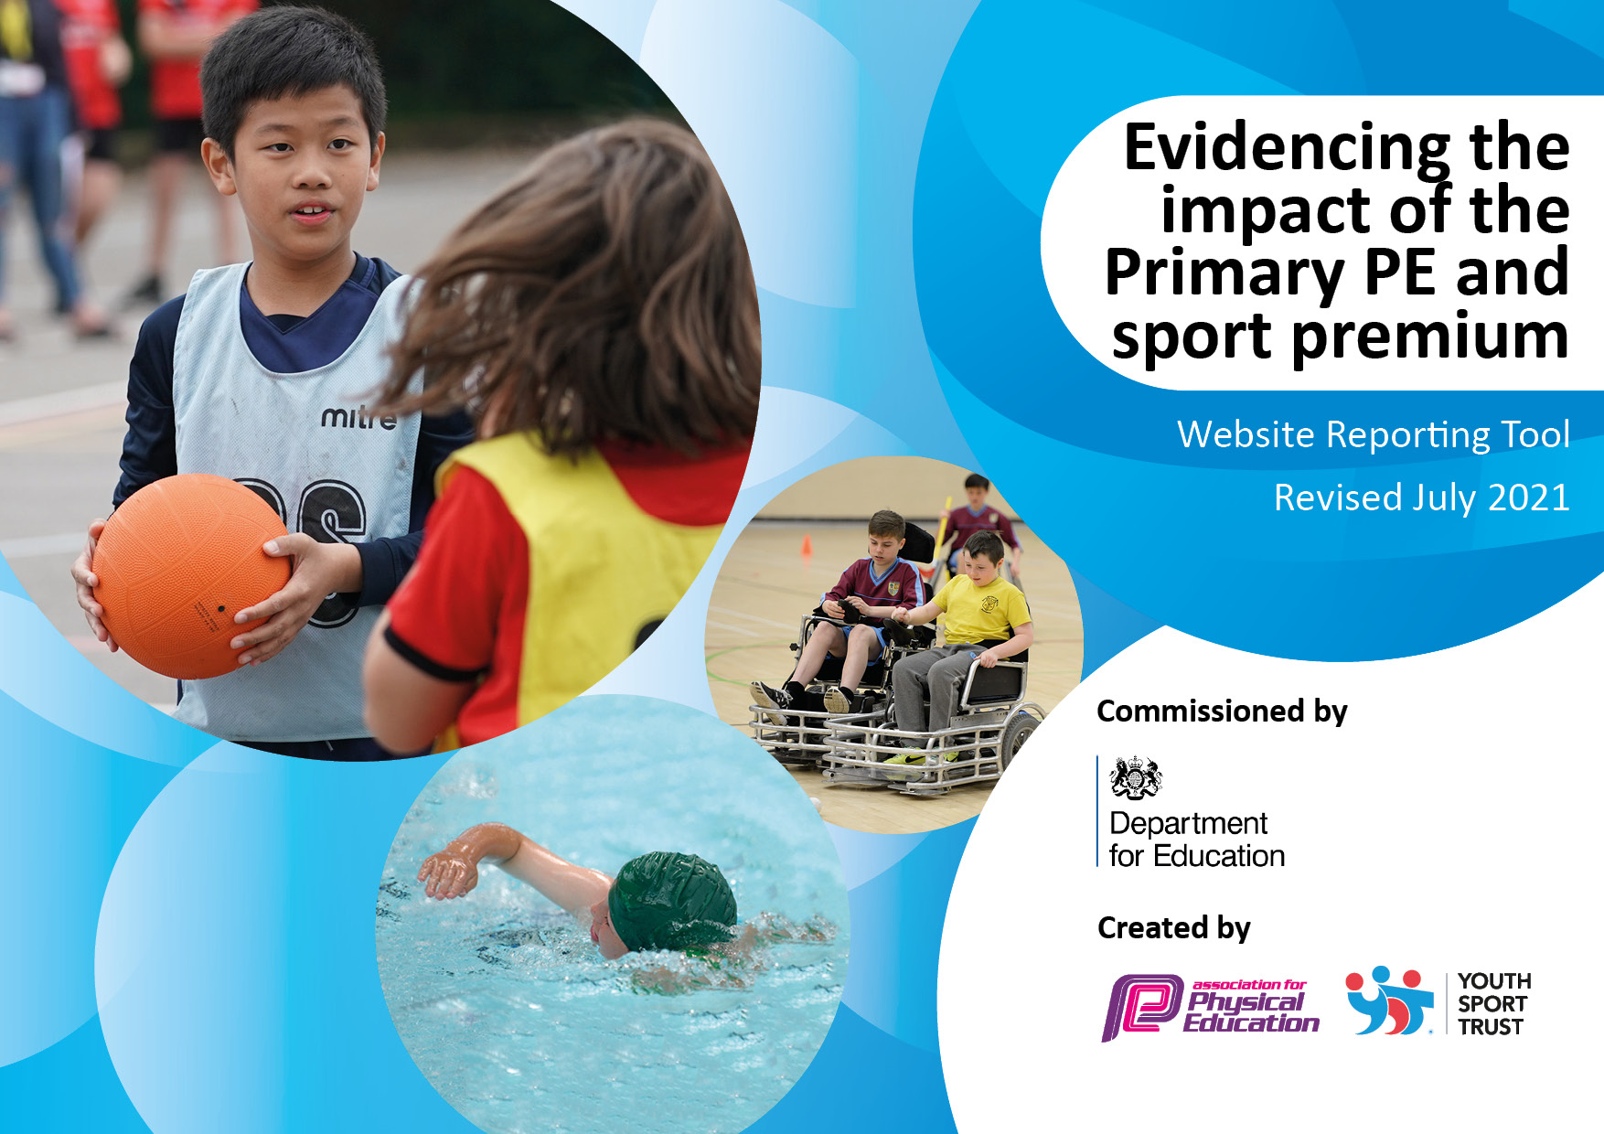
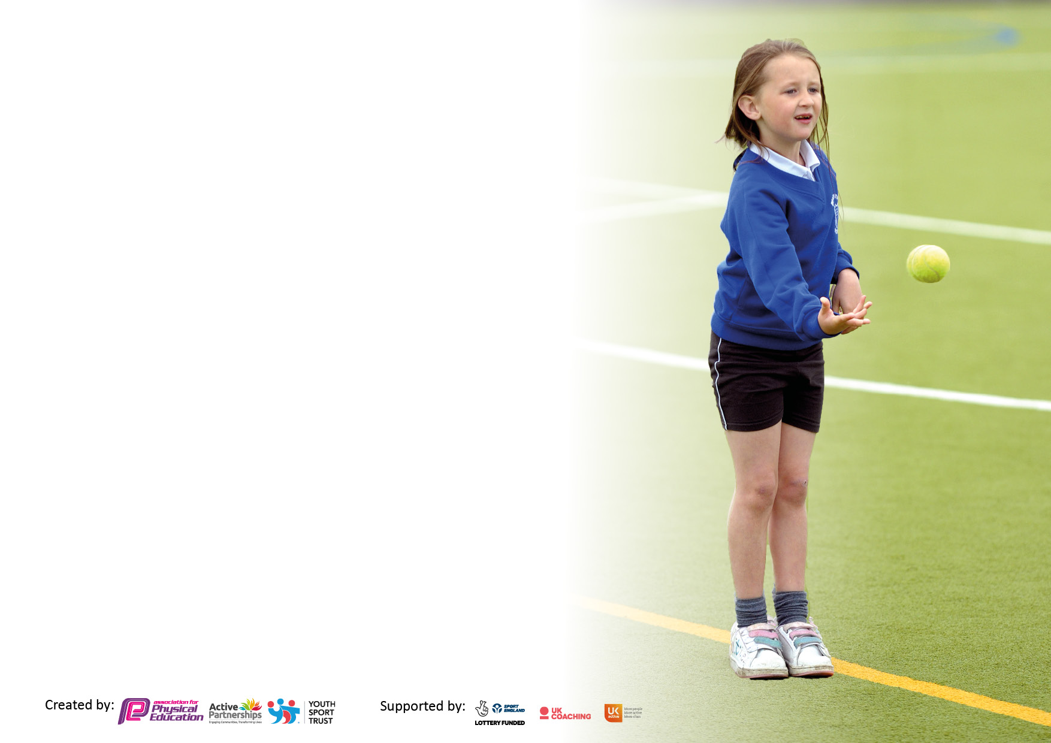

It is important that your grant is used effectively and based on school need. The Education Inspection Framework makes clear there will be a focus on ‘whether leaders and those responsible for governors all understand their respective roles and perform these in a way that enhances the effectiveness of the school’.

Under the Quality of Education Ofsted inspectors consider:
Intent - Curriculum design, coverage and appropriateness
Implementation - Curriculum delivery, Teaching (pedagogy) and Assessment
Impact - Attainment and progress

To assist schools with common transferable language this template has been developed to utilise the same three headings which should make your plans easily transferable between working documents.

Schools must use the funding to make additional and sustainable improvements to the quality of Physical Education, School Sport and Physical Activity (PESSPA) they offer. This means that you should use the Primary PE and sport premium to:

- Develop or add to the PESSPA activities that your school already offer
- Build capacity and capability within the school to ensure that improvements made now will benefit pupils joining the school in future years
- The Primary PE and sport premium should not be used to fund capital spend projects; the school’s budget should fund these.

Pleasevisitgov.ukfortherevisedDfEguidanceincludingthe5keyindicatorsacrosswhichschoolsshoulddemonstrate animprovement.Thisdocumentwillhelpyoutoreviewyourprovisionandtoreportyourspend.DfEencouragesschools to use this template as an effective way of meeting the reporting requirements of the Primary PE and sport premium.

We recommend you start by reflecting on the impact of current provision and reviewing the previous spend.

Schools are required to publish details of how they spend this funding, including any under-spend from 2019/2020, as well as on the impact it has on pupils’ PE and sport participation and attainment. All funding must be spent by 31st July 2022.

We recommend regularly updating the table and publishing it on your website throughout the year. This evidences your ongoing self-evaluation of how you are using the funding to secure maximum, sustainable impact. Final copy must be posted on your website by the end of the academic year and no later than the 31st July 2021. To see an example of how to complete the table please click HERE.
Created by: Supported by:

Details with regard to funding
Please complete the table below.

Total amount carried over from 2021/2022 | £0
Total amount allocated for 2022/2023 | £18,884.00
Total amount of funding for 2022/23. To be spent and reported on by 31st July 2023 | £18,884.00
Swimming Data
Please report on your Swimming Data below.

Meeting national curriculum requirements for swimming and water safety.

N.B. Complete this section to your best ability. For example you might have practised safe self-rescue techniques on dry land which you can then transfer to the pool when school swimming restarts.
Due to exceptional circumstances priority should be given to ensuring that pupils can perform safe self rescue even if they do not fully meet the first two requirements of the NC programme of study
What percentage of your current Year 6 cohort swim competently, confidently and proficiently over a distance of at least 25 metres?  N.B. Even though your pupils may swim in another year please report on their attainment on leaving primary school at the end of the summer term 2021.  Please see note above | 96%
What percentage of your current Year 6 cohort use a range of strokes effectively [for example, front crawl, backstroke and breaststroke]?  Please see note above | 92%
What percentage of your current Year 6 cohort perform safe self-rescue in different water-based situations? | 96%
Schools can choose to use the Primary PE and sport premium to provide additional provision for swimming but this must be for activity over and above the national curriculum requirements. Have you used it in this way? | No Due to the backlog at our local pool, we are unable to book top-up sessions this year.

Action Plan and Budget Tracking
Capture your intended annual spend against the 5 key indicators. Clarify the success criteria and evidence of impact that you intend to measure to evaluate for pupils today and for the future.

Academic Year: 2022/2023 | Total fund allocated: £18,884.00 | Date Updated: October 2022  Review date: May 2023
Key indicator 1: The engagement of all pupils in regular physical activity – Chief Medical Officers guidelines recommend that primary school pupils undertake at least 30 minutes of physical activity a day in school |  |  |  | Percentage of total allocation:
 |  |  |  | 43.7%
Intent | Implementation |  | Impact
Your school focus should be clear what you want the pupils to know and be able to do and about  what they need to learn and to  consolidate through practice: | Make sure your actions to achieve are linked to your intentions: | Funding allocated: | Evidence of impact: what do pupils now know and what can they now do? What has changed? | Sustainability and suggested next steps:
Increase the activity levels if children during break and lunchtimes. | Investment in outdoor play equipment for KS1 (climbing frame set plus installation). | £7,557.49  Actual: £3,017.66 | PE Coordinator to liaise with KS1 staff to ascertain best items for purchase. Conversations to be had regarding level of impact. We have been unable to confirm plans with the manufacturer/ builder for this year so we are holding these plans until next year – this will be discussed in September. We did however invest in some playground markings to encourage children to participate in more active lunchtimes. Observations and feedback from the MTA’s have shown that these have been very popular with the children. | Investing in durable, high quality kit will ensure that it can impact many children for years to come.
Increase the activity levels of children. Raise motivation for participation. | Purchase Half Marathon t-shirts and medals so children can enter. | £700  Actual: £0 | PE Coordinator to monitor participation through the activity tracker. Children asked to complete a questionnaire after they attend the event. Cost of medals and t-shirts included with equipment in KI2. 125 children took part in the challenge, meaning that ran 1 mile every week and then culminated in a final mile and celebration of their hard work. | Covering the signup fee and providing t shirts will ensure that this is not a barrier to participation. We are aiming to provide a positive experience in PESSPA in order to encourage life-long participants.

Key indicator 2: The profile of PESSPA being raised across the school as a tool for whole school improvement |  |  |  | Percentage of total allocation:
 |  |  |  | 4.2%
Intent | Implementation |  | Impact
Your school focus should be clear what you want the pupils to know and be able to do and about  what they need to learn and to  consolidate through practice: | Make sure your actions to achieve are linked to your intentions: | Funding allocated: | Evidence of impact: what do pupils now know and what can they now do? What has changed? | Sustainability and suggested next steps:
Positively impact the teaching and learning in PE. | Update and replenish equipment for use in PE lessons and extra-curricular clubs. | £500  Actual: £1,663.13 | Liaise with staff and complete an equipment audit to ensure that the new scheme of work is well resourced. Conversations had with teachers during term 1, with a list of potential purchases. Equipment audit completed in Term 1. Purchases to resource lessons and clubs. Every child in every PE lesson has access to enough equipment to maximise their practice time. Cost also includes medals purchased for the Half Marathon. | Ensuring that the curriculum is well resourced, will mean that all children are able to make progress quickly and allow them to excel.
Raise the profile of the Sports leadership program to encourage more children to be involved. Increase the activity levels during lunchtimes. | Jumpers for Sports Leaders. | £300  Actual: £132 | PE Coordinator to observe and take photos during lunchtimes of the Playleaders working with other children. Speak to the Sports Council about their thoughts on the impact of the leaders and whether they think they sweatshirts help to promote the role. 12 sports leaders attended the Primary Leadership Conference and also worked with our PE Specialist from the PSSP. These children are on a rota to lead games and active play with other children during lunchtimes. Investment in their jumpers has made them highly visible and has given the role prestige, increasing ambition of other children to take on the role in the future. | Investing in high quality sweatshirts will ensure that they can be used by next years’ leaders as well. Raising the profile of leadership will encourage more children to access and engage with sport in a variety of roles.
Positively impact teaching and learning in PE. | Purchased new PE scheme of work for the whole school. Purchased Cross Curricular Orienteering. | Actual: £603 | This year we invested in a new scheme of work to be implemented across the whole school. We chose the Cambridgeshire scheme as it came widely recommended and the lesson plans are comprehensive and straight forward to use by non-specialists. We also invested in a Cross Curricular Orienteering scheme to support our teachers in their delivery of OAA. | By providing high quality, easy to use lesson plans, we are supporting our teachers to deliver high quality PE.

Key indicator 3: Increased confidence, knowledge and skills of all staff in teaching PE and sport |  |  |  | Percentage of total allocation:
 |  |  |  | 27.5%
Intent | Implementation |  | Impact
Your school focus should be clear | Make sure your actions to | Funding | Evidence of impact: what do | Sustainability and suggested
what you want the pupils to know | achieve are linked to your | allocated: | pupils now know and what | next steps:
and be able to do and about | intentions: |  | can they now do? What has
what they need to learn and to |  |  | changed?:
consolidate through practice:
Positively impact teaching and learning in PE. | Employ the PSSP to provide bespoke CPD for all teachers. | £4,500  Actual: £4,500 | All staff to complete feedback forms following any CPD.  Confidence levels to be monitored through this feedback and further training arranged where necessary. Our affiliation with the PSSP has meant that we can access PE Specialist support for staff CPD. 6 teachers have worked alongside our specialist and all have reported an increase of confidence levels in their delivery. PE Coordinator attended the Primary PE Conference and subsequently has enabled them to review the curriculum provision in more detail. | Continued affiliation with the PSSP will ensure that we can access on-going support for staff. Investment in staff is a priority as they are our most sustainable and effective resource.
Positively impact teaching and learning in PE. | Annual subscription to iMoves to provide staff with high quality dance and gymnastics plans and resources. | £697  Actual: £697 | Staff survey to be completed in Term 5 to ascertain the usefulness of the resources. PE assessment data to be collated following dance and gymnastics units. PE Coordinator has liaised with staff and we are now going to research alternative provision for next year as resources were used but only partially and it could be that we only need Dance resources. | Providing teachers with high quality plans will increase confidence and positively impact teaching and learning in PE.

Key indicator 4: Broader experience of a range of sports and activities offered to all pupils |  |  |  | Percentage of total allocation:
 |  |  |  | 33.8%
Intent | Implementation |  | Impact
Your school focus should be clear | Make sure your actions to | Funding | Evidence of impact: what do | Sustainability and suggested
what you want the pupils to know | achieve are linked to your | allocated: | pupils now know and what | next steps:
and be able to do and about | intentions: |  | can they now do? What has
what they need to learn and to |  |  | changed?
consolidate through practice:
Increase activity levels and participation. | Book Wheelchair Basketball to provide an alternative experience for children during Sports Week. | £120  Actual: £700 | Child surveys to be conducted after the event to gauge impact. PE Coordinator to track participation through the Activity Tracker and liaise with staff with regards to whether it was a successful/positive experience. This year as well as Wheelchair Basketball, we had ‘Circus into Schools’ for Sports Week. Every child in the school had the opportunity to take part and all children and staff reported how inspiring it was and it created a real buzz around physical activity and PE. | Providing alternative activities will encourage more children to participate and develop new interests. Providing positive experiences in PE and school sport will encourage life-long participants.
Increase engagement in extracurricular activity. | Employ Argyle to deliver some after school clubs. | £6,270  Actual: £6,290 | Club registers to be maintained. PE Coordinator to use activity tracker to monitor participation. Feedback forms to be collected once they have completed any CPD with staff. Argyle have worked with all classes across the school to provide specialist sessions and support staff. This program to be reviewed at the end of the academic year with the Head Teacher and PE Coordinator. Costs also include entry fee to the clusters league. | Employing specialist coaches will ensure that we can offer a diverse range of clubs to engage more children.  Providing a positive experience in PESSPA will encourage lifelong participants.

Key indicator 5: Increased participation in competitive sport |  |  |  | Percentage of total allocation:
 |  |  |  | 2.9%
Intent | Implementation |  | Impact
Your school focus should be clear | Make sure your actions to | Funding | Evidence of impact: what do | Sustainability and suggested
what you want the pupils to know | achieve are linked to your | allocated: | pupils now know and what | next steps:
and be able to do and about | intentions: |  | can they now do? What has
what they need to learn and to |  |  | changed?
consolidate through practice:
Increased participation in competitive events and activities. | Employ the PSSP to run competitions/events and leadership training for children in all year groups. | *Cost in KI3 | PSSP to send termly reports to monitor the number of events we engage with. PE Coordinator to monitor participation through the activity tracker. We have attended 9 events this year, providing opportunities for over 93 children. 12 children attended the Sports Leadership conference. | Providing children with positive experiences in PE and school sport will encourage life-long participants.
Increased participation in competitive events and activities. | Book transport and cover release costs for staff to attend events. | £500  Actual: £1,231.31 | PSSP to send termly reports to monitor the number of events we engage with. PE Coordinator to monitor participation through the activity tracker. There has been a transport issue across the city this year which has meant that costs have increased significantly. We have attended 9 events this year, providing opportunities for over 93 children. 12 children attended the Sports Leadership conference. | By providing transport, we negate this as a barrier to participation. Releasing staff from class will help us to get as many children to as many events as possible.
Increased participation in competitive events and activities. | Purchase Sports Day badges. | £49.90  Actual: £49.90 | Children from all year groups across the school took part in competitive events where they had the chance to win a badge. PE Coordinator to track participation. Purchase for sports day will take place in Term 5 ready for the event in Term 6. | Based on success in previous years, we will continue to invest in these as an incentive to children to strive for their best in suitable, competitive events.

Signed off by
Head Teacher: | DLWilson
Date: | 14/09/2023
Subject Leader: | G. Maunder
Date: | 14/09/2023
Governor: | M. Forster
Date: | 14/09/2023

